Safety Rules for Rip N’ Dip
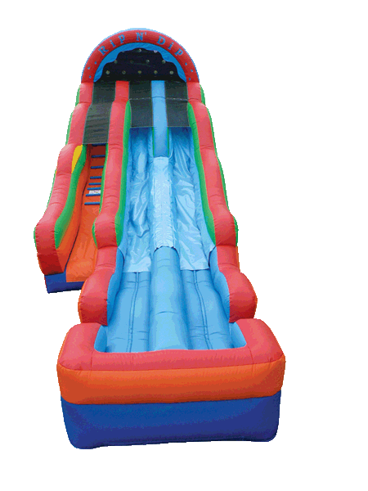

AN ADULT MUST BE SUPERVISING AT ALL TIME!

*NO shoes *NO Sharp objects *NO Glasses *NO Jewelry *NO Rough play
*NO Tumbling or Flipping *NO Medical conditions *NO Expecting Mothers *NO Pets
*NO SILLY STRING OR SAND (AUTOMATIC $1000.00 CHARGE if we find it on the slide!!!)
*NO FOOD, DRINKS, SOAP, CONDITIONER, SHAMPOO, ETC on slide if found on slide there is a $75 cleaning charge.

One Person Per Slide Must go down feet first Do not hang out in slide area
Keep landings clear NEVER allow anyone on the slide while it’s inflating and deflating

SHUTDOWN if winds are 10mph or higher! SHUTDOWN if lightening or thundering

Maximum Number of kids is 3 at a time Maximum weight limit per person is 175lbs

DO NOT PULL, PUSH, OR HANG ON NETTING!!! YOU ARE RESPONSIBLE FOR ANY DAMAGES THAT OCCUR WHILE IN YOUR POSSESSION!!!

